## Reports/Inventory/Return To Stock Reports /Amber vial Activated Inventory Report:

Request:

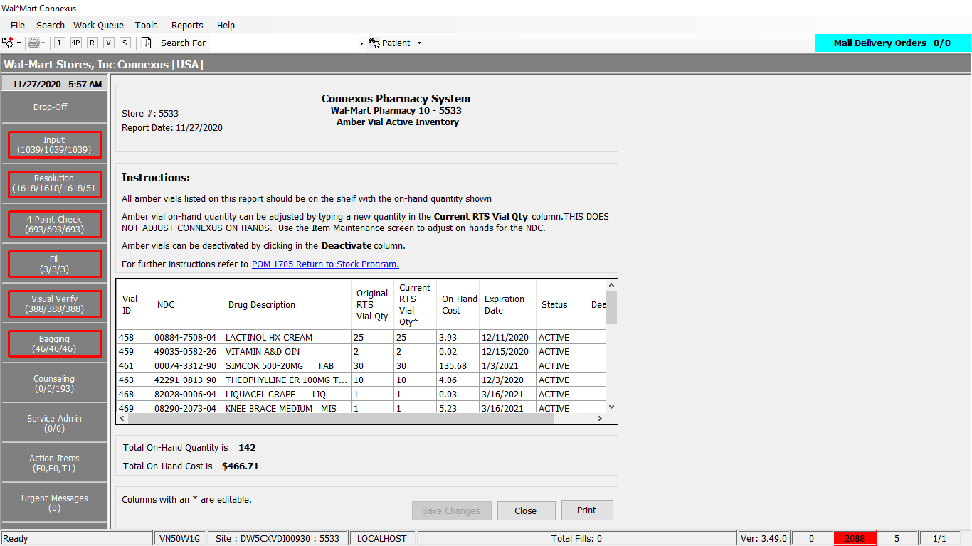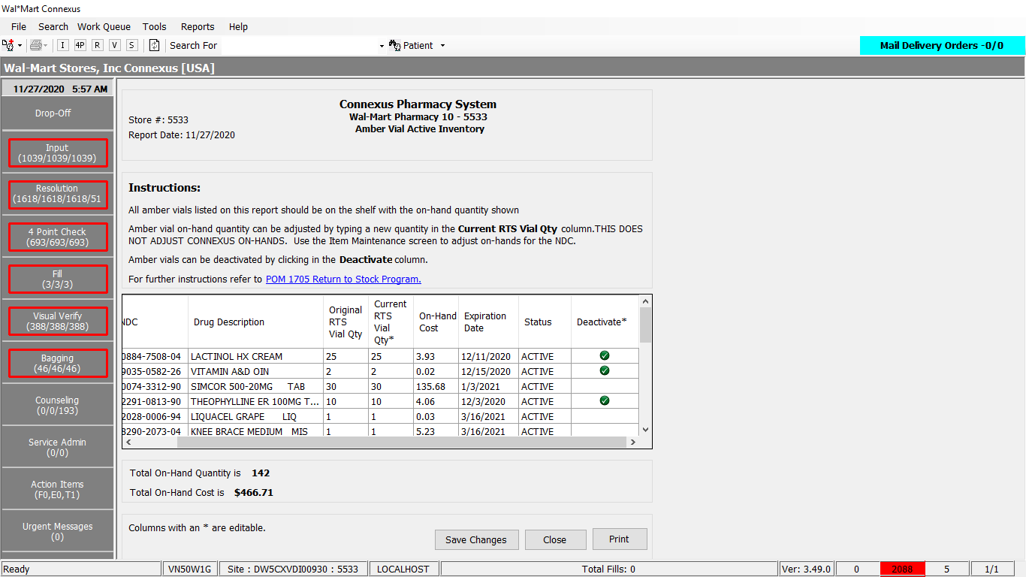

Response:



Queries:

1. Public Const GetReturnToStockInfo As String = "SELECT pi.ndc_nbr, pp.short_name, rv.vial_expiration_date,rv.create_ts, " &

" pic.phm_item_cost_amt, rv.last_change_userid, rv.item_qty, rv.mds_fam_id, " &

" rfi.fill_item_qty, rv.rts_vial_id, rvst.rts_vial_status_desc, rv.last_change_ts, rv.rts_vial_status_code " &

" FROM rts_vial rv " &

" JOIN pharmacy_item pi " &

" ON pi.mds_fam_id = rv.mds_fam_id " &

" JOIN pharmacy_product pp " &

" ON pp.product_mds_fam_id = pi.product_mds_fam_id " &

" JOIN rx21c:rx_fill_item rfi " &

" ON rfi.rx_fill_id= rv.rx_fill_id" &

" JOIN pharmacy_offering:phm_item_cost pic " &

" ON ( pi.mds_fam_id = pic.mds_fam_id " &

" AND pic.cost_type_code = 3001 " &

" AND pic.effective_date = (SELECT MAX(effective_date) " &

" FROM pharmacy_offering:phm_item_cost pic2 " &

" WHERE pi.mds_fam_id = pic2.mds_fam_id " &

" AND pic2.cost_type_code = 3001 )) " &

" JOIN rts_vial_status_txt rvst " &

" ON rvst.rts_vial_status_code = rv.rts_vial_status_code "

2. Public Const RTSDeactivatedCondition As String = " WHERE rv.rts_vial_status_code = ? " &

" AND DATE(rv.last_change_ts) BETWEEN ? AND ? " &

" ORDER BY rv.last_change_ts ASC "

3. Public Const RTSExpiryDaysAllStatusCondition As String = " WHERE rv.rts_vial_status_code in (?,?) " &

" AND DATE(rv.vial_expiration_date) BETWEEN ? AND ? " &

" ORDER BY pp.short_name ASC "

4. Public Const RTSExpiryDaysStatusCondition As String = " WHERE rv.rts_vial_status_code in (?) " &

" AND DATE(rv.vial_expiration_date) BETWEEN ? AND ? " &

" ORDER BY pp.short_name ASC "

5. Public Const RTSActiveCondition As String = " WHERE rv.rts_vial_status_code = ? " &

" AND DATE(rv.vial_expiration_date) > CURRENT " &

" ORDER BY rv.rts_vial_id ASC "

6. Public Const RTSInventoryCreateDateCondition As String = " AND DATE(rv.create_ts) BETWEEN ? AND ? ORDER BY rv.rts_vial_id ASC "

7. Public Const RTSInventoryLastChangeDateCondition As String = " AND DATE(rv.last_change_ts) BETWEEN ? AND ? ORDER BY rv.rts_vial_id ASC "

8.Public Const RTSInventoryVialRangeCondition As String = " AND rts_vial_id BETWEEN ? AND ? ORDER BY rv.rts_vial_id ASC "

Dal:

Public Function GetReturnToStockInfo(ByVal siteId As Integer, ByVal ReportOptions As Integer,

ByVal fromDate As Date, ByVal toDate As Date,

ByVal fromVialId As Integer, ByVal toVialId As Integer,

Optional ByVal expiryItemStatus As String = "ALL") _

As List(Of ReturnToStockInfoBE) Implements IItemDAL.GetReturnToStockInfo

Using (New Tracer(ConnexusCommonConstants.ConnexusTracer))

Dim returnToStockInfo As New List(Of ReturnToStockInfoBE)

Dim paramList As New List(Of DbParameter)

Dim querySQL As New StringBuilder

Dim local As New LocalizationManager

querySQL.Append(DataAccess.ItemQueries.GetReturnToStockInfo)

'And the filter criteria as per the report option selected.

Select Case ReportOptions

'Filter and Order by condition for the Amber vials deactivated

Case AmberVialReport.RTSDeactivatedVialReport

querySQL.Append(ItemQueries.RTSDeactivatedCondition)

paramList.AddParameter(DbType.Int32, AmberVialStatus.Deactivated)

paramList.AddParameter(DbType.Date, fromDate)

paramList.AddParameter(DbType.Date, toDate)

'Filter and Order by condition for the Amber vial expiring in the user input number of days.

Case AmberVialReport.RTSNearExpirationReport

Select Case expiryItemStatus

Case "ALL"

querySQL.Append(String.Format(ItemQueries.RTSExpiryDaysAllStatusCondition))

paramList.AddParameter(DbType.Int32, AmberVialStatus.Deactivated)

paramList.AddParameter(DbType.Int32, AmberVialStatus.Active)

Case "ACTIVE"

querySQL.Append(String.Format(ItemQueries.RTSExpiryDaysStatusCondition))

paramList.AddParameter(DbType.Int32, AmberVialStatus.Active)

Case "DEACTIVE"

querySQL.Append(String.Format(ItemQueries.RTSExpiryDaysStatusCondition))

paramList.AddParameter(DbType.Int32, AmberVialStatus.Deactivated)

End Select

paramList.AddParameter(DbType.Date, fromDate)

paramList.AddParameter(DbType.Date, toDate)

'Filter and order by condition for the Amber Vial Active Inventory

Case AmberVialReport.RTSActiveInventoryReport

querySQL.Append(ItemQueries.RTSActiveCondition)

paramList.AddParameter(DbType.Int32, AmberVialStatus.Active)

'Filter and order by condition for the RTS Inventory.

'With create date range condition

Case AmberVialReport.RTSInventoryCreateDate

'Append the query for the date range.

querySQL.Append(ItemQueries.RTSInventoryCreateDateCondition)

paramList.AddParameter(DbType.Date, fromDate)

paramList.AddParameter(DbType.Date, toDate)

'Filter and order by condition for the RTS Inventory.

'With last change date range condition

Case AmberVialReport.RTSInventoryLastChange

'Append the query for the date range.

querySQL.Append(ItemQueries.RTSInventoryLastChangeDateCondition)

paramList.AddParameter(DbType.Date, fromDate)

paramList.AddParameter(DbType.Date, toDate)

'Filter and order by condition for the RTS Inventory.

'With vial range condition

Case AmberVialReport.RTSInventoryVialRange

'Append the query for vial id range.

querySQL.Append(ItemQueries.RTSInventoryVialRangeCondition)

paramList.AddParameter(DbType.Int32, fromVialId)

paramList.AddParameter(DbType.Int32, toVialId)

End Select

Using dr As IDataReader = ExecuteReader(DatabaseEnum.Pharmacy_Offering, siteId, querySQL.ToString, paramList)

'Retrieve data from datareader to data entity

While dr.Read

Dim amberVialInfo As New ReturnToStockInfoBE

With amberVialInfo

.NDC = String.Format(local, "{0:N}", dr.GetValueOrDefault(Of String)("ndc_nbr").SafeTrim)

.Description = dr.GetValueOrDefault(Of String)("short_name").SafeTrim

.ExpirationDate = dr.GetValueOrDefault(Of DateTime)("vial_expiration_date").Date

.CreateDate = dr.GetValueOrDefault(Of DateTime)("create_ts").Date

.UnitCost = dr.GetValueOrDefault(Of Decimal)("phm_item_cost_amt")

.UserId = dr.GetValueOrDefault(Of String)("last_change_userid").SafeTrim

.VialQuantity = (dr.GetValueOrDefault(Of Decimal)("item_qty"))

'Original Vial Quantity will be the fill quantity in case of RTS Inventory view

If ReportOptions = AmberVialReport.RTSInventoryVialRange OrElse

ReportOptions = AmberVialReport.RTSInventoryCreateDate OrElse

ReportOptions = AmberVialReport.RTSActiveInventoryReport OrElse

ReportOptions = AmberVialReport.RTSInventoryLastChange Then

.OriginalVialQuantity = (dr.GetValueOrDefault(Of Decimal)("fill_item_qty"))

Else

.OriginalVialQuantity = .VialQuantity

End If

'This property will hold the current vial quantity and keeps track of the changes in the Return-To-Stock view

.OriginalQuantity = .VialQuantity

.MdsfamId = dr.GetValueOrDefault(Of Integer)("mds_fam_id")

.VialId = dr.GetValueOrDefault(Of Int32)("rts_vial_id")

.Status = dr.GetValueOrDefault(Of String)("rts_vial_status_desc")

.LastChangets = dr.GetValueOrDefault(Of DateTime)("last_change_ts")

.StatusCode = dr.GetValueOrDefault(Of Int16)("rts_vial_status_code")

End With

returnToStockInfo.Add(amberVialInfo)

End While

Return returnToStockInfo

End Using

End Using

End Function